How to capture the network traces on the RMX

Log in as SUPPORT:SUPPORT account
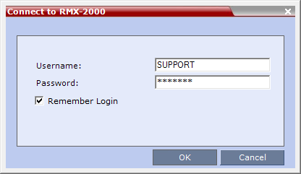

Then go to Administration – Tools – Network Traffic Capture:
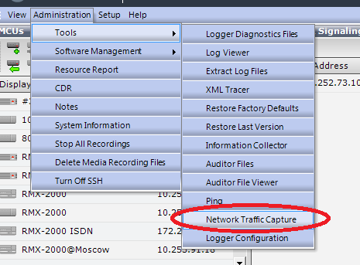

In opened window select all the signaling interface and all of the media resources you have as well as a desired maximum size of capture and duration of the capture period:
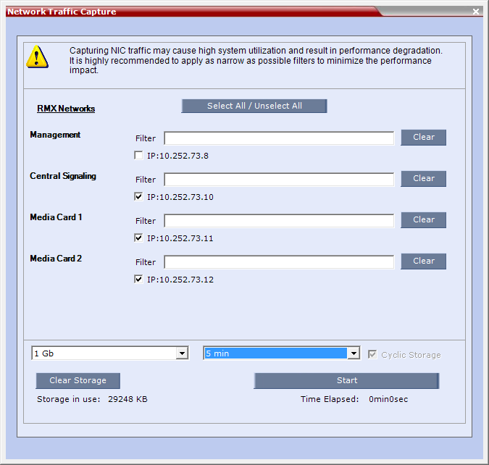

Please note, after you press “Start” countdown timer will starts as well and capture will automatically stopped in the specified time irrelevant to the call flow. Press the START button.
Answer “Yes” in the next window:
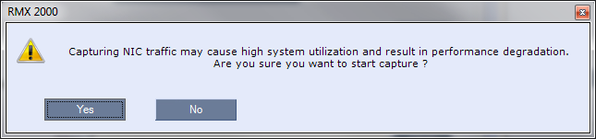
Then make the call and recreate the issue. After you finish press the STOP button:
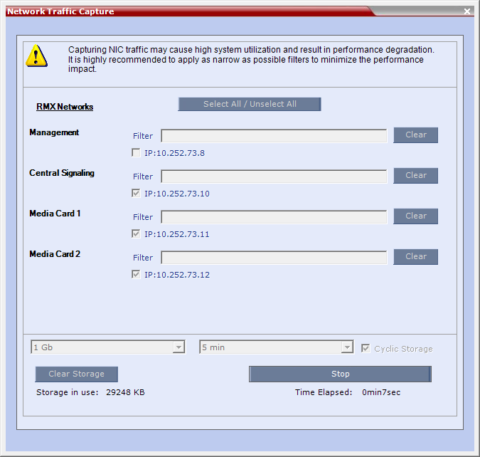

Close the window and go to Administration -> Tools -> Information Collector
In addition to preselected log files select the “Network Traffic Capture” feature as well as “System logs” and “Fault logs” so the log files list would look as follows:
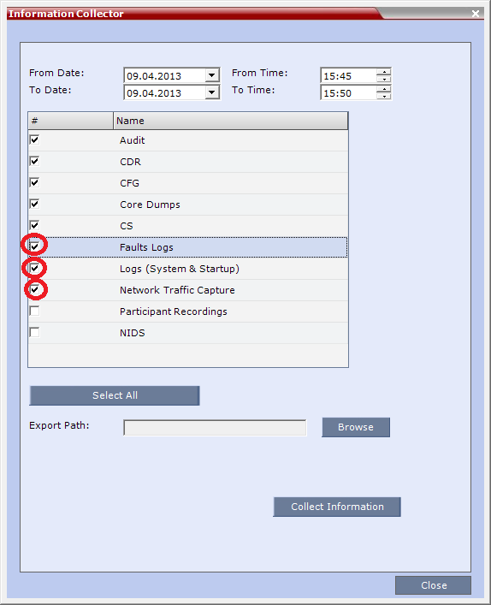
Don’t forget to point at the correct time range in order to cover the issue recreation period:
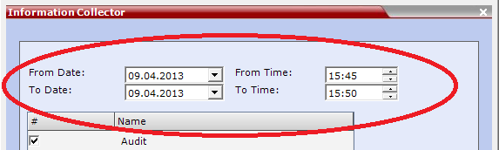
Select the export path and retrieve all the logs by pressing “Collect information”:
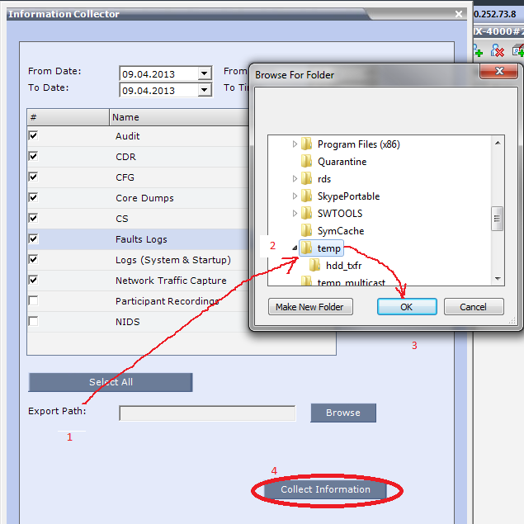:

After you’ve done open the archive you’ve just pulled from the RMX and check the “Logs” and “Output/tcp_dump” for existence – there should be log files as well as *.cap files:
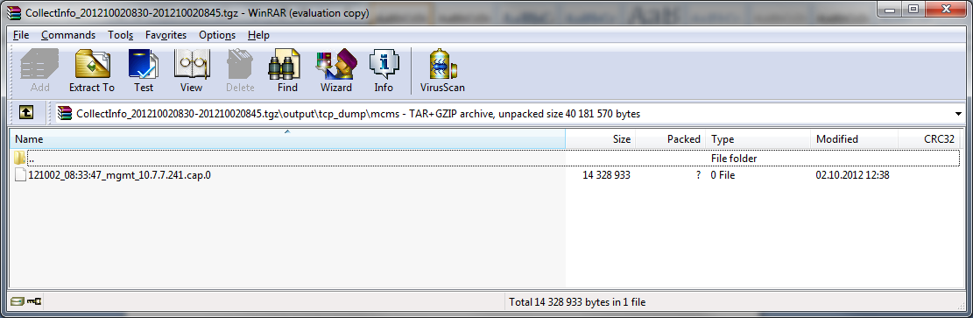
Log files:
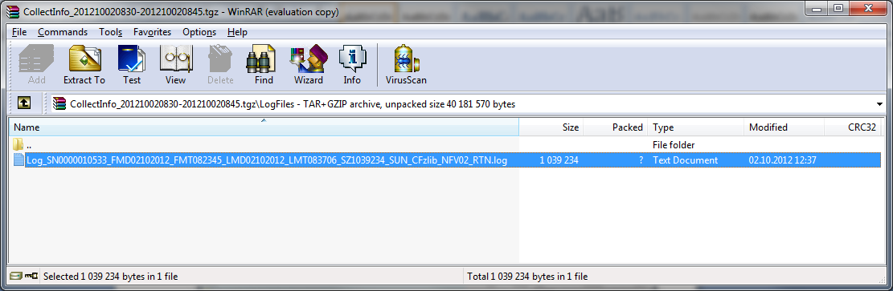

Please make sure you have all these files in the collected log so we could analyze them in details.

