In order to continue our investigation I would need the following logs from the RMX (to get those please login with SUPPORT user, if it doesn’t exist please create it as administrator of the RMX):

* The loggers Diagnostics Files Covering the time of the issue.

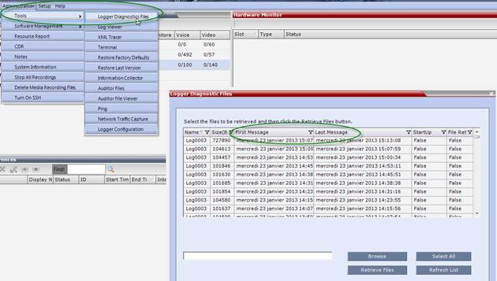

* The formatted CDR of the conference(s) that was impacted by the problem.

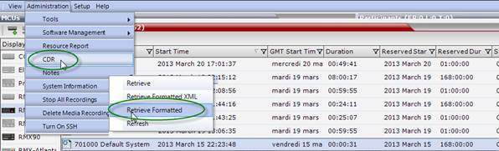

* The FullFaultsList of your system.

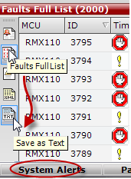

Please do not hesitate to contact me if you have any question or additional details regarding this ticket.